Sixth GEWEX/LS4P International Workshop
(9 am – 5:30 pm CST, Sunday, December 14, 2025)

Objectives
The 6th GEWEX/LS4P Workshop (i.e., the 3rd GEWEX/LS4P-II Workshop) will present recent LS4P-related research and achievements, report current status of the LS4P Phase II, and present the preliminary LS4P-II experimental results. Potential research issues for the LS4P-II will be elucidated and discussed.

Venue
Room Strand 12 on the 2nd floor, Hyatt Regency New Orleans (in person) and online everywhere

Hotel Hyatt Regency New Orleans, 601 Loyola Ave, New Orleans, LA 70113, Tel: 504-613-3720
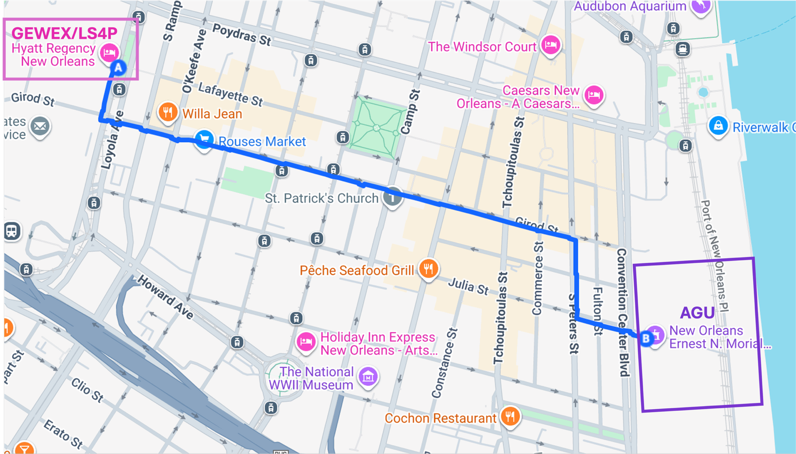

2nd Floor Map in 2 perspectives

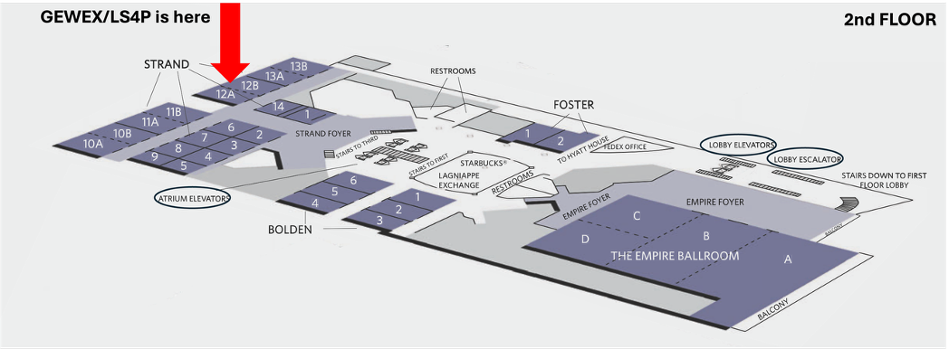

Sixth GEWEX/LS4P International Workshop Agenda
9 am – 5:30 pm CST, Sunday, December 14, 2025
(All times are New Orleans times (CST))

9:00-9:15 |  | Participants self-introduction
Session I (Chair: Aaron Boone, Meteo France)
9:15-9:30 | Xubin Zeng  (Univ. of Arizona, USA) |  | GEWEX and Perspectives on S2S Predictability
9:30-9:45 | Cristiana Stan  (Geoge Mason University, USA) |  | The legacy of the WCRP/WRRP S2S Prediction Project and the emerging directions
9:45-10:00 | Anne Verhoef/Yijian Zeng  (U. Reading U.K./ UT-ITC, Netherlands) |  | Outcomes of the SoilWat_2025 workshop and planned collaborative activities’
10:00-10:15 | Shaocheng Xie (LLNL/DOE, USA) |  | GEWEX/Global Atmospheric System Studies (GASS): Current activities and future plan
10:15-10:30 | Ruby Leung  (PNNL/DOE, USA) |  | Synergistic Role of Land and Ocean in Earth System Predictability Inferred from E3SM with Weakly Coupled Land and Ocean Data Assimilation
10:30-10:45 | Coffee Break
Session II (Chair: Qi Tang, LLNL/DOE, USA)
10:45-11:00 | Yang Zhang  (NJU, China) |  | The Tibetan Plateau–Rocky Mountain Circumglobal Wave Train in Observations and Modeling
11:00-11:15 | Jaeyoung Song  (KIAPS/KMA, Korea) |  | KIM-Based LS4P Experiments: LSM Impacts, Experimental Protocol, and Key Findings
11:15-11:30 | Retish Senan  (ECMWF) |  | Impact of snow data assimilation over the Tibetan Plateau on S2S prediction
11:30-11:45 | Jinbo Xie  (Princeton Univ., USA) |  | Enhanced orographic drag sustains remote land forcing of high mountain on the seasonal precipitation
11:45-12:00 | Miao Yu  (NUIST, China) |  | Responses of June Precipitation in Eastern China to Spring Soil Temperature Anomaly over the Qinghai-Xizang Plateau under Differing Snow-cover and Jet-stream conditions
12:00-12:15 | Iman Khadir/Sam Shen (SUSD, USA) |  | Demonstration of using the FourCastNet AI weather forecasting model to make global predictions for 15 days and beyond
12:15-12:30 | Xiao Duo Pan  (TPR, China) |  | Accelerating Earth System Science at the National Tibetan Plateau Data Center
12:30-13:45 | Lunch
13:45-14:00 | Group Photo
Session III (Chair: Michael Ek, NCAR, USA)
14:00-14:15 | Meg Fowler and Cenlin He (NCAR, USA) | Harnessing land-atmosphere interactions to enhance subseasonal-to-seasonal predictability
14:15-14:30 | Mark Olsen (NOAA Weather Program Office, USA) | NOAA S2S Program: recent activities and overview
14:30-14:45 | Yuhei Takaya  (MRI/JMA, Japan) | Soil moisture-surface temperature interaction  in monsoons
14:45-15:00 | Hongjing Chen/Xin-Zhong Liang  (SYSU, China/UMD, USA) | Evolution of Tibetan Plateau Land-Surface Temperature Anomalies: Warm–Cold Asymmetry in Model Sensitivity
15:00-15:15 | Shiori Sugimoto  (JAMSTEC, Japan) | Land–atmosphere coupling processes controlling near-surface temperature over the Tibetan Plateau
15:15-15:25 | ARDILOUZE Constantin/Aaron Boone | LS4P phase 2 : CNRM first results using the enthalpy adjustment method
15:25-15:45 | Coffee Break
15:45-17:15 | Moderator: Yongkang Xue (UCLA, USA) | Discussions of the LS4P-II achievement, results and plan
18:00- | Dinner and Social (free participation)

In-person Participants

NO | NAME | INSTITUTION | EMAIL
1 | Ali Ganem, Khalil | UCLA, USA | khalilganem@g.ucla.edu
2 | Boone, Aaron | Meteo France | aaron.boone@meteo.fr
3 | Cao, Zhijiong | UCLA, USA | czj9763@g.ucla.edu
4 | Chen, Hongjing | Sun Yat-Sen University, China | chenhj43@mail2.sysu.edu.cn
5 | Ek, Michael | NSF NCAR, USA | ek@ucar.edu
6 | Ferguson, Craig R. | NASA Science S2S Program, USA | craig.r.ferguson@nasa.gov
7 | Fowler, Meg | NSF NCAR, USA | mdfowler@ucar.edu
8 | Leung, Ruby | PNNL/DOE, USA | ruby.leung@pnnl.gov
9 | Li, Yishen | Lawrence Berkeley National Laboratory, USA | yishenli@lbl.gov
10 | Liang, Xin-Zhong | University of Maryland, College Park, USA | xliang@umd.edu
11 | Olsen, Mark | NOAA Weather Program Office, USA | mark.olsen@noaa.gov
12 | Pan, Xiaoduo | Institute of Tibetan Plateau Research, CAS, China | panxd@itpcas.ac.cn
13 | Qian, Yun | PNNL/DOE, USA | yun.qian@pnnl.gov
14 | Qiu, Yuan | Arizona State University | Yuan.Qiu.2@asu.edu
15 | Richter, Jadwiga (Yaga) | NSF NCAR, USA | jrichter@ucar.edu
16 | Senan, Retish | ECMWF | retish.senan@ecmwf.int
17 | Sugimoto, Shiori | Japan Agency for Marine Earth Science and Technology | shiorisug@jamstec.go.jp
18 | Takaya, Yuhei | MRI, JMA, Japan | yuhei.takaya@mri-jma.go.jp
19 | Tang, Qi | LLNL/DOE, USA | tang30@llnl.gov
20 | Van Oevelen, Peter | International GEWEX Project Office, USA | pvanoevelen@gewex.org
21 | Wang, Aihui | Institute of Atmospheric Physics (IAP), CAS, China | wangaihui@mail.iap.ac.cn
22 | Wang, Guilin | University of Connecticut, USA | guiling.wang@uconn.edu
23 | Xie, Jinbo | Princeton University, USA | jinbo.xie@princeton.edu
24 | Xue, Yongkang | UCLA, USA | yxue@geog.ucla.edu
25 | Yu, Miao | Nanjing University of Information Science and Technology, China | yum@nuist.edu.cn
26 | Zhang, Lily | University of Washington, USA | lnzhang@uw.edu

Remote Participants

NO | NAME | INSTITUTION | EMAIL
1 | Adeaga, Olusegun | University of Lagos, Nigeria | oadeaga@unilag.edu.ng
2 | Brunke, Michael | University of Arizona, USA | brunke@arizona.edu
3 | Chen, Chu-Chun | University of Connecticut, USA | chu-chun.chen@uconn.edu
4 | Chou, Sin Chan | CPTEC, INPE, Brazil | chou.sinchan@gmail.com
5 | Diallo, Ismaila | San Jose State University, USA | idiallo.work@gmail.com
6 | He, Cenlin | NSF NCAR, USA | cenlinhe@ucar.edu
7 | Kim, Hyungjun | Korea Advanced Institute of Science & Technology | hyungjun.kim@kaist.ac.kr
8 | Kim, Jeong-Hun | The University of Tokyo, Japan | j.khun1209@gmail.com
9 | Kong, Xianghui | IAP, CAS, China | kongxianghui@mail.iap.ac.cn
10 | Lin, Changgui | NSSC, CAS, China | linchanggui@nssc.ac.cn
11 | Nakamura, Tetsu | MRI, JMA, Japan | te2nakamur@mri-jma.go.jp
12 | Hara Prasad Nayak | Indian Institute Of Technology (IIT) Bhubaneswar | hpmaths@gmail.com
13 | Li, Shuting | Nanjing University, China | dz21280004@smail.nju.edu.cn
14 | Li, Yue | UCLA, USA | yli@geog.ucla.edu
15 | Lu, Lixin | Colorado State Univ., USA | lixin.lu@colostate.edu
16 | Owanda, Vincent | Technical University of Kenya, Kenya | vinnywandros@gmail.com
17 | Saha, Subodh Kumar | Indian Institute of Tropical Meteorology | subodh@tropmet.res.in
18 | Shen, Samuel | San Diego State University, USA | sshen@sdsu.edu
19 | Song, Jaeyoung | KIAPS, KMA, Korea | jysong@kiaps.org
20 | Stan, Cristiana | George Mason University, USA | cstan@gmu.edu
21 | Verhoef, Anne | University of Reading, UK | a.verhoef@reading.ac.uk
22 | Wang, Hailan | NOAA NCEP/Climate Prediction Center, USA | hailan.wang@noaa.gov
23 | Wei, Xiaocheng | Colorado State Univ., USA | xiaocheng.wei@colostate.edu
24 | Winters, Andrew | University of Colorado, USA | andrew.c.winters@colorado.edu
25 | Wu, Chenglai | IAP, CAS, China | wuchenglai@mail.iap.ac.cn
26 | Xie, Shaocheng | LLNL, DOE, USA | xie2@llnl.gov
27 | Yang, Kun | Tsinghua University, China | yangk@tsinghua.edu.cn
28 | Zeng, Jijian | UT-ITC, Netherlands | y.zeng@utwente.nl
29 | Zeng, Weizhong | NCEP, NOAA, USA | weizhong.zheng@noaa.gov
30 | Zeng, Xubin | University of Arizona, USA | xubin@arizona.edu
31 | Zhang, Hongliang | CEMC, Chinese Meteorological Administration | zhanghl@cma.gov.cn
32 | Zhang, Yang | Nanjing University, China | yangzhang@nju.edu.cn

